LSTM Model Research for Intrusion Detection
Why LSTM:
- LSTM (Long Short-Term Memory) is a type of Recurrent Neural Network (RNN) specialized for sequence data.
- Network traffic behaves sequentially over time — attacks develop as patterns (e.g., repeated failed logins, DDoS bursts).
- LSTM can remember long-term dependencies, making it ideal for detecting such evolving threats.

Advantages of LSTM
- Captures Temporal Behavior: Understands time-based attack trends that static models (like Random Forest) miss.
- Avoids Vanishing Gradient: Uses gates (input, forget, output) to control memory flow and retain key information.
- High Accuracy: Proven to reach 95–99% detection accuracy on datasets like CIC-IDS2017.
- Explainable: Attention-based LSTM can show which time steps contributed most to an alert.
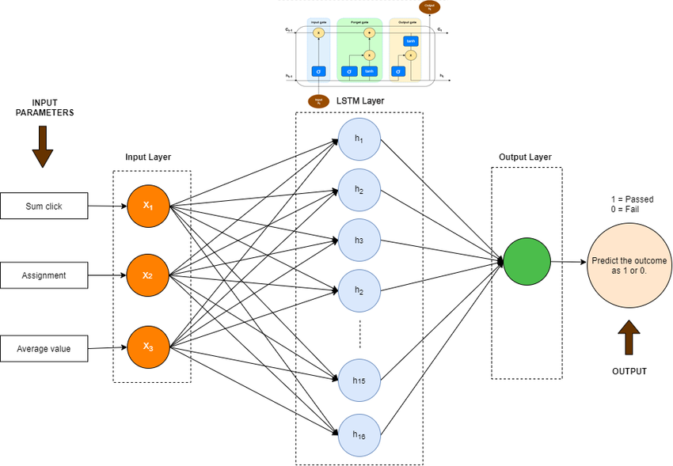
- Lightweight & Real-Time: Faster inference compared to large Transformers — suitable for deployment.

Architecture of LSTM Model:

LSTM Architecture Overview
Input Layer → LSTM Layers (2) → Dense Layer → Sigmoid/Softmax Output
- Input: Sequential flow features (duration, packet rate, bytes, flags, etc.)
- Hidden Layers: 2 Bi-directional LSTM layers (128 units each, dropout 0.2)
- Output:
  - Binary: Normal (0) / Attack (1)
  - Multiclass: DDoS, Port Scan, Brute Force, etc.

Training Configuration
- Dataset: CIC-IDS2017 (contains normal + 15 attack types)
- Data Split: 70% train, 15% validation, 15% test (time-based split preferred)
- Loss Function: Binary Cross-Entropy / Categorical Cross-Entropy
- Optimizer: Adam or AdamW
- Batch Size: 64–128
- Epochs: 30–50
- Metrics: Accuracy, Precision, Recall, F1-Score, ROC-AUC

